Greenhills simulator PPC

Perquisites :

1. Multi installation and license.
2. Integrirty installation.
3. Kernel project – kernel image (kernel) , and script to load kernel (kernel.p)
4. Greenhills integrate files.
5. Scripts to run the executable on simulator, as dynamic load module.
6. Custom VC Execute script (execute.bat).
7. Custom VC STDOUT files
8. Custom VC CCAST (CCAST_CFG)
9. Rnserver – c project.
10. VC Env.

The kernel project :

Using monolith.

We need to have support for socket

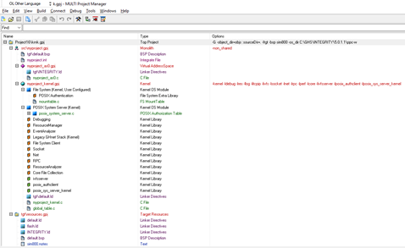

Project Configuration:

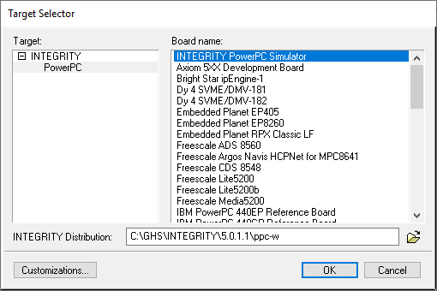

Kernel configuration:

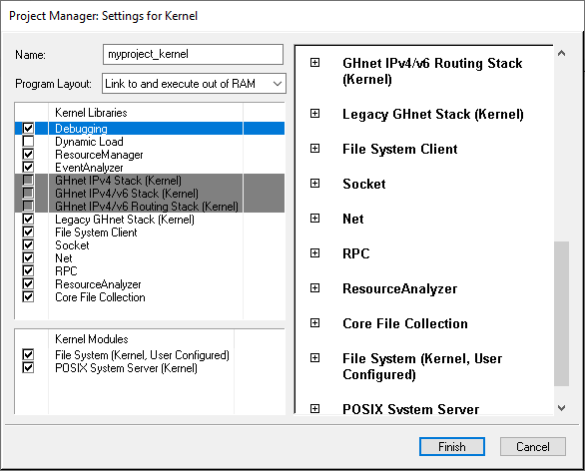

Start_VC.BAT

set VECTORCAST_DIR=c:\vcast2019

SET PATH=C:\GHS\multi_614;C:\GHS\comp_201354;%PATH%

SET VC_GHS_OS_DIR=C:\GHS\INTEGRITY\5.0.1.1\ppc-w

%VECTORCAST_DIR%\vcastqt -lc -Emanager

VCAST configuration:

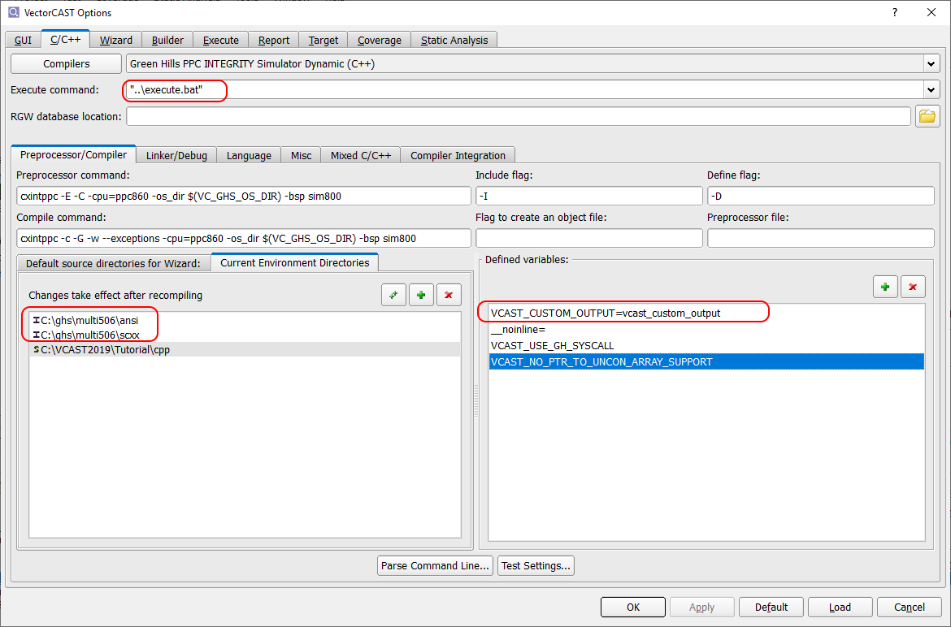

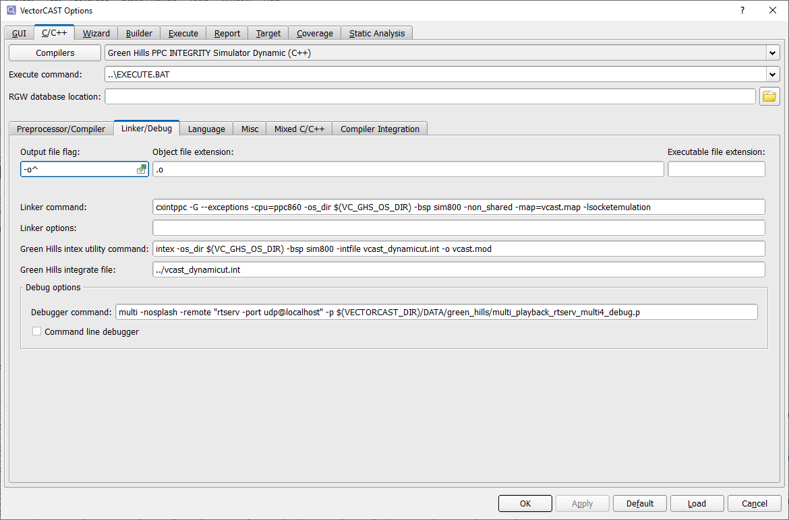

Custom files :

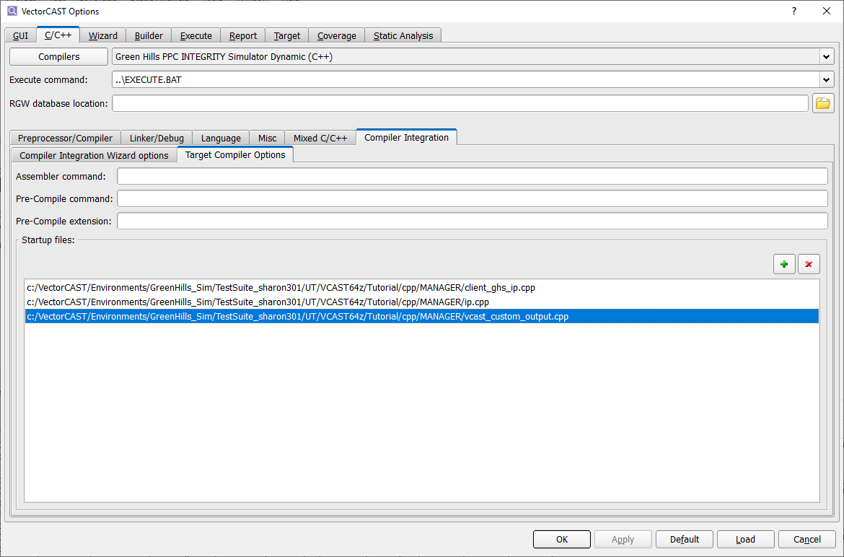

Setting IP

//IP.CPP

int ip0 = 192;

int ip1 = 168;

int ip2 = 16;

int ip3 = 31;

THE EXECUTE.BAT

set STARTDIR=%CD%

@tasklist /fi "imagename eq rnserver.exe" |find ":" > nul

if errorlevel 1 taskkill /f /im rnserver.exe

@tasklist /fi "imagename eq multi.exe" |find ":" > nul

if errorlevel 1 taskkill /f /im multi.exe

if exist vcast_stdout.dat del /Q vcast_stdout.dat

cd ..

if exist vcast_stdout.dat del /Q vcast_stdout.dat

if exist VCAST.END del /Q VCAST.END

start/MIN rnserver.exe

start/MIN multi -nosplash -remote "isimppc" kernel -p kernel_play.p

sleep 5

start/MIN multi -nosplash -remote "rtserv -port udp@localhost" -p multi_playback_rtserv_multiut.p %1

:wait

if exist VCAST.END goto type_dat

sleep 1

goto wait

:type_dat

type vcast_stdout.dat

@tasklist /fi "imagename eq multi.exe" |find ":" > nul

if errorlevel 1 taskkill /f /im multi.exe

@tasklist /fi "imagename eq rnserver.exe" |find ":" > nul

if errorlevel 1 taskkill /f /im rnserver.exe

cd %STARTDIR%

exit /B 0